Facility Use Permit

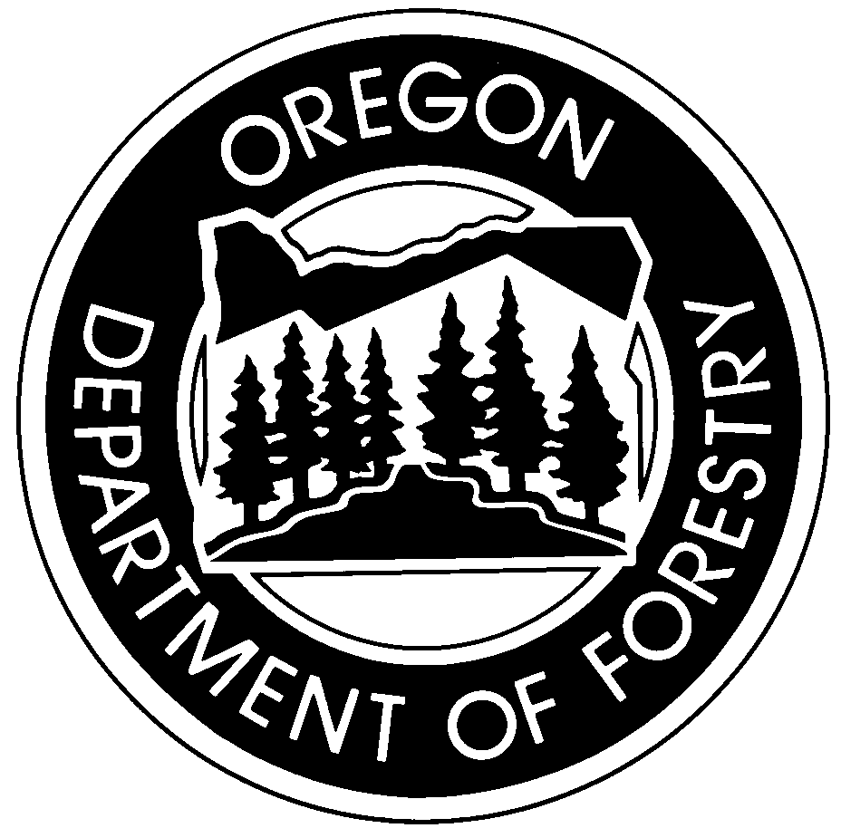
Tillamook Forest Center
Janet McLennan Community Room

Date and hours of event: «reservationdate»
Approved renter: «firstname» «lastname»
Permit issued by: Jen Warren, Tillamook Forest Center
Date permit issued: «date»
Receipt number: «receiptnumber»
This form is your Facility Use Permit. You must have this permit with you on the day of your event. You are authorized to use only the Community Room at the Tillamook Forest Center only on the date indicated above. Receipt of this permit indicates that you have signed a facility rental agreement, and understand and agree to adhere to the use policies. Please read the back of this permit for reminders about our policies.

Access to the facility
Unless other arrangements have been made and you have paid the after-hours staffing fee, this permit only provides you access to the Community Room during center business hours. In general, these hours are 8:00 am to 4:30 pm, Wednesday through Sunday in the spring and fall; and 9:00 am to 5:30 pm, seven days a week during the summer. Please contact the Visitor Services Coordinator if you determine you will need access outside of these hours or if you are unsure about the hours available to you.

Cancellation policy
You may receive a refund of your fee (minus a $25 administrative charge) if you cancel no less than one month prior to your event. Cancellations after that date will receive a refund equal to half the total rental fee. Please contact the Visitor Services Coordinator to cancel.

Refund of damage/cleaning deposit
You will receive a checklist of Community Room cleaning responsibilities when you arrive. After your event the room will be inspected by our staff. If you have completed all the tasks in the closing checklist and our staff have confirmed that the facility is in good condition, your damage deposit will be refunded. Please note that failure to complete the closing checklist will result in forfeiture of a portion or your entire deposit. Return of your deposit may take up to 30 days.

Enjoy your time at the Tillamook Forest Center.
It is a special place; help us keep it that way by taking care of it.

Jen Warren Date
Permit Issuer

Facility Rental Policy Reminders
Tillamook Forest Center

Please note that this is not the complete list, but is intended to provide a reminder of the policies you have agreed to adhere to. By signing the facility rental agreement you agree to follow all policies included in the rental packet you received prior to rental confirmation. If you have any questions about these policies, please contact the Visitor Services Coordinator at the Tillamook Forest Center – (503) 815-6808 or jen.e.warren@oregon.gov. Violating any of the full rental policies may result in termination of your event and forfeiture of your fee and deposit.
Alcohol
Beer and wine are allowed; no hard alcohol. Minors may not consume or possess alcohol at any time. You are responsible for anyone consuming alcohol during your event. Any alcohol sales require and OLCC permit. Please see the OLCC website at www.oregon.gov/OLCC/LIC for any questions regarding permits or licensing.
Amplified sound
Volume must be kept low as background music. Audio must not be audible from outside the Community Room.
Cleaning
You are responsible for cleaning the Community Room after your event. You will be provided a cleaning/closing checklist when you arrive. All items must be completed in order to receive a deposit refund. Request cleaning supplies from Tillamook Forest Center staff when you are ready to clean.
Fires
Fires are only allowed in the fireplace. Only wood may be burned—no plastic or trash. BBQ/smoker trailers, personal charcoal grills and fire pits are not allowed during. Real-flame candles are not allowed at any time.
Group size
Group size is limited to a maximum of 75 people (total children and adults). The space can comfortably accommodate up to 75 seated in chairs, but much fewer if tables are used.
Hours
This permit allows you to have access to the Community Room on the day of your rental only during the approved hours. In the summer (Memorial Day to Labor Day), approved hours are 9:00 am to 5:30 pm. During the spring and fall, approved hours are 8:00 am to 4:30 pm. The facility must be clean and closed no later than the approved closing time.
Insurance
You may be required to obtain special event insurance (required for events taking place outside of Tillamook Forest Center operating hours). Contact your insurance provider to purchase coverage. Proof of insurance must be provided to the Visitor Services Coordinator no later than one month before your event. Failure to provide proof of insurance will result in your event being canceled. Please see the full rental information packet you were provided for specific language required to be included in your proof of insurance.
Parking
Limited parking is available. Please encourage your guests to carpool. Spaces may not be reserved in any manner at any time. Large vehicles (buses, RVs, catering trucks, etc.) must park in RV spaces and are not permitted to occupy more than one space each. Parking is not permitted in fire lanes at any time. You are responsible for ensuring that you, any hired caterers or other providers, and your guests follow these policies.
Public use
The Tillamook Forest Center and surrounding recreation sites are highly-popular and are frequently crowded during the busy summer season. The public has permission to use the Center facilities (parking, picnic tables, restrooms, etc.) during your event. Reserving or blocking access to any of the public facilities is not permitted. Please be considerate of other forest users to ensure everyone enjoys their visit.

